**PYTHON LABORATORY**

**Exercise No:11**

**Date:22/11/2020**

**Aim:**

Write a Python program to find the greatest common divisor (gcd) of two integers using recursion.

**Program:**

def gcd(a,b):

if(b==0):

return a

else:

return gcd(b,a%b)

a=int(input("Enter First Number:"))

b=int(input("Enter Second Number:"))

GCD=gcd(a,b)

print("GCD is:")

print(GCD)

**Output:**

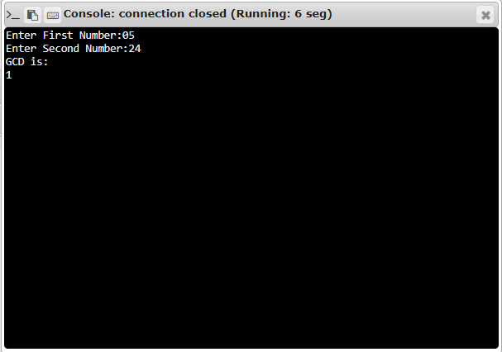

**Link:**

[**http://103.53.53.18/mod/vpl/forms/edit.php?id=326&userid=1708#**](http://103.53.53.18/mod/vpl/forms/edit.php?id=326&userid=1708)

**RESULT:**

The greatest common divisor (gcd) of two integers using recursion is successfully obtained.